ONEWAY Memory BY Age
/STATISTICS DESCRIPTIVES HOMOGENEITY WELCH
/PLOT MEANS
/MISSING ANALYSIS.

Oneway

Notes
Output Created |  | 05-May-2019 23:18:56
Comments
Input | Active Dataset | DataSet0
Input | Filter | <none>
Input | Weight | <none>
Input | Split File | <none>
Input | N of Rows in Working Data File | 30
Missing Value Handling | Definition of Missing | User-defined missing values are treated as missing.
Missing Value Handling | Cases Used | Statistics for each analysis are based on cases with no missing data for any variable in the analysis.
Syntax |  | ONEWAY Memory BY Age  /STATISTICS DESCRIPTIVES HOMOGENEITY WELCH  /PLOT MEANS  /MISSING ANALYSIS.
Resources | Processor Time | 00 00:00:00.156
Resources | Elapsed Time | 00 00:00:00.164

[DataSet0]

Descriptives
 | N | Mean | Std. Deviation | Std. Error | 95% Confidence Interval for Mean
 |  |  |  |  | Lower Bound | Upper Bound
18 | 1 | 73.0000 | . | . | . | .
19 | 2 | 77.7500 | 18.38478 | 13.00000 | -87.4307 | 242.9307
20 | 2 | 64.0000 | 12.02082 | 8.50000 | -44.0027 | 172.0027
21 | 2 | 88.0000 | 18.38478 | 13.00000 | -77.1807 | 253.1807
22 | 9 | 71.0100 | 11.13879 | 3.71293 | 62.4480 | 79.5720
23 | 1 | 92.2500 | . | . | . | .
24 | 1 | 77.2500 | . | . | . | .
25 | 1 | 100.7500 | . | . | . | .
28 | 2 | 67.5000 | 4.24264 | 3.00000 | 29.3814 | 105.6186
30 | 1 | 106.2500 | . | . | . | .
41 | 1 | 135.0000 | . | . | . | .
43 | 1 | 140.0000 | . | . | . | .
48 | 3 | 142.0000 | 18.33030 | 10.58301 | 96.4650 | 187.5350
52 | 1 | 124.0000 | . | . | . | .
56 | 1 | 166.0000 | . | . | . | .
58 | 1 | 158.0000 | . | . | . | .
Total | 30 | 94.4030 | 33.66618 | 6.14658 | 81.8318 | 106.9742

Descriptives
 | Minimum | Maximum
18 | 73.00 | 73.00
19 | 64.75 | 90.75
20 | 55.50 | 72.50
21 | 75.00 | 101.00
22 | 48.00 | 83.25
23 | 92.25 | 92.25
24 | 77.25 | 77.25
25 | 100.75 | 100.75
28 | 64.50 | 70.50
30 | 106.25 | 106.25
41 | 135.00 | 135.00
43 | 140.00 | 140.00
48 | 126.00 | 162.00
52 | 124.00 | 124.00
56 | 166.00 | 166.00
58 | 158.00 | 158.00
Total | 48.00 | 166.00

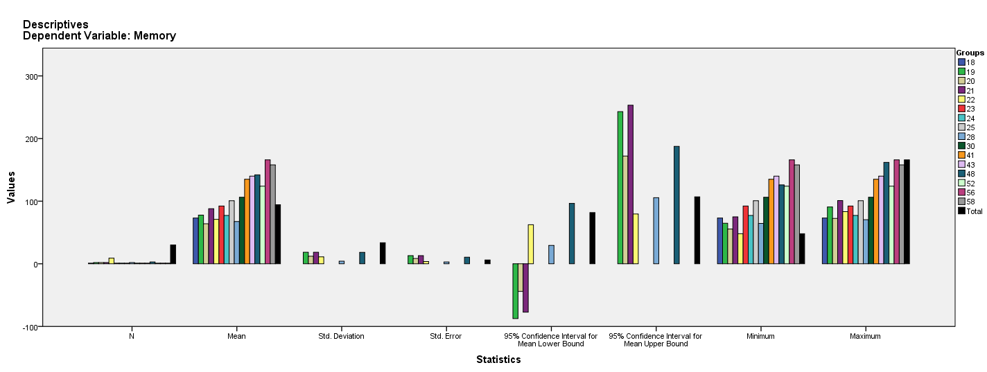

Test of Homogeneity of Variances
Memory
Levene Statistic | df1 | df2 | Sig.
1.042ª | 5 | 14 | .432
a. Groups with only one case are ignored in computing the test of homogeneity of variance for Memory.

ANOVA
Memory
 | Sum of Squares | df | Mean Square | F | Sig.
Between Groups | 30365.864 | 15 | 2024.391 | 11.323 | .000
Within Groups | 2503.081 | 14 | 178.792
Total | 32868.945 | 29

Robust Tests of Equality of Means^{b}
Memory
 | Statisticª | df1 | df2 | Sig.
Welch | . | . | . | .
a. Asymptotically F distributed.
b. Robust tests of equality of means cannot be performed for Memory because at least one group has the sum of case weights less than or equal to 1.

Means Plots

